KW Trams

KW 006i Standard 3 window balcony headlamp open top car.

Parts
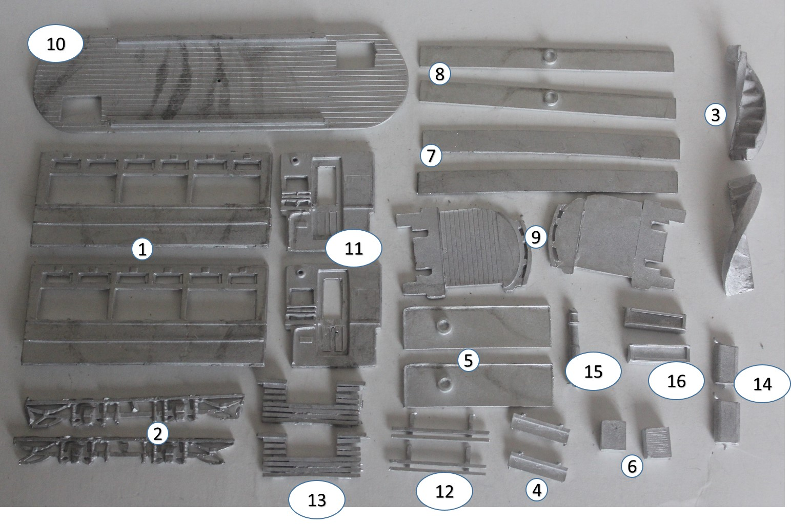

- Tram side 3 window x2
- Truck side x2
- Stairs x2
- Step x2
- Dash panel x2
- Resistance box x2
- Upper decency panel sides x2
- Upper decency panel ends x2
- Platform x2
- Upper floor x1
- Lower deck bulkhead x2
- Life guard x2
- Life tray x2
- Controller x2
- Trolley mast x1
- Destination box x2

Build Steps

- Attach truck sides to body sides ensuring exact centrality.
- Fix bulk heads to sides squarely and marry subassemblies to produce a box effect.
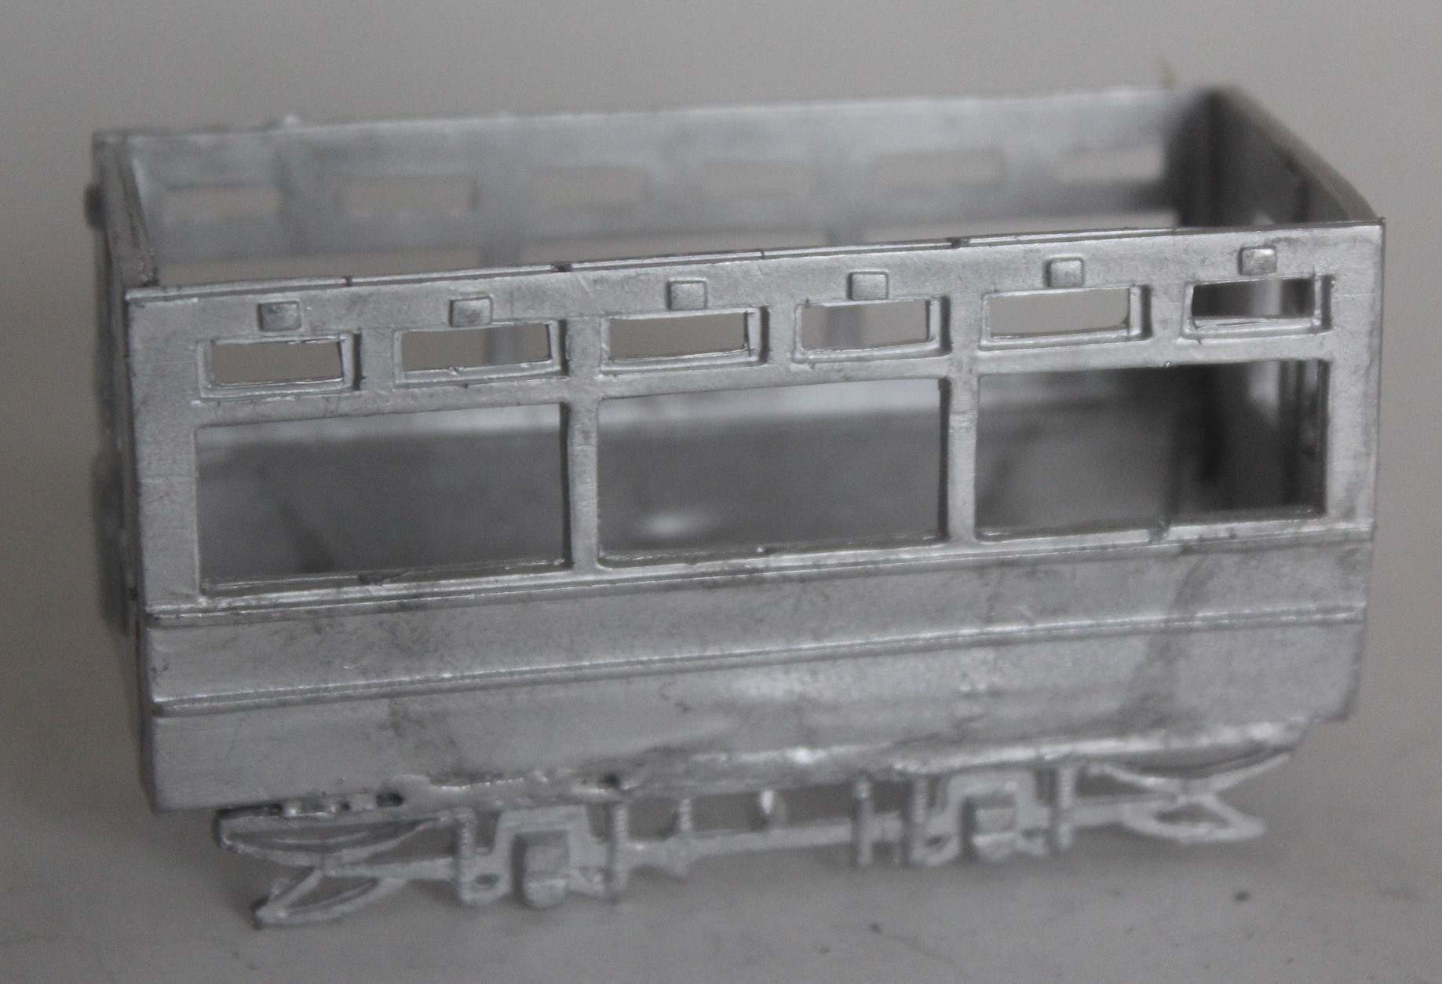
- With model inverted, attach platforms to bottom edges of bulkheads; ensuring the lip is within the body and not on the platform.
- Carefully bend the dash panels to fit the curve of the platform, trim to length and fit to platform.
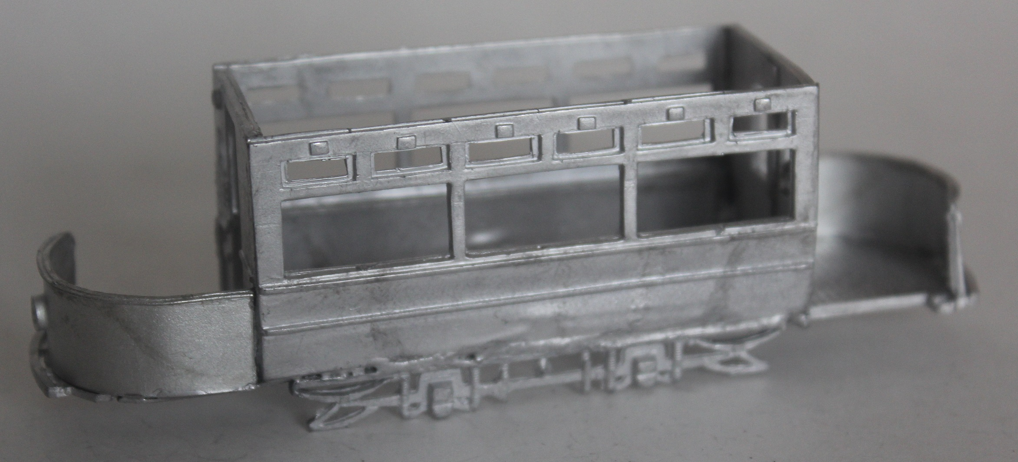
- Fix the ceiling/upper deck floor piece
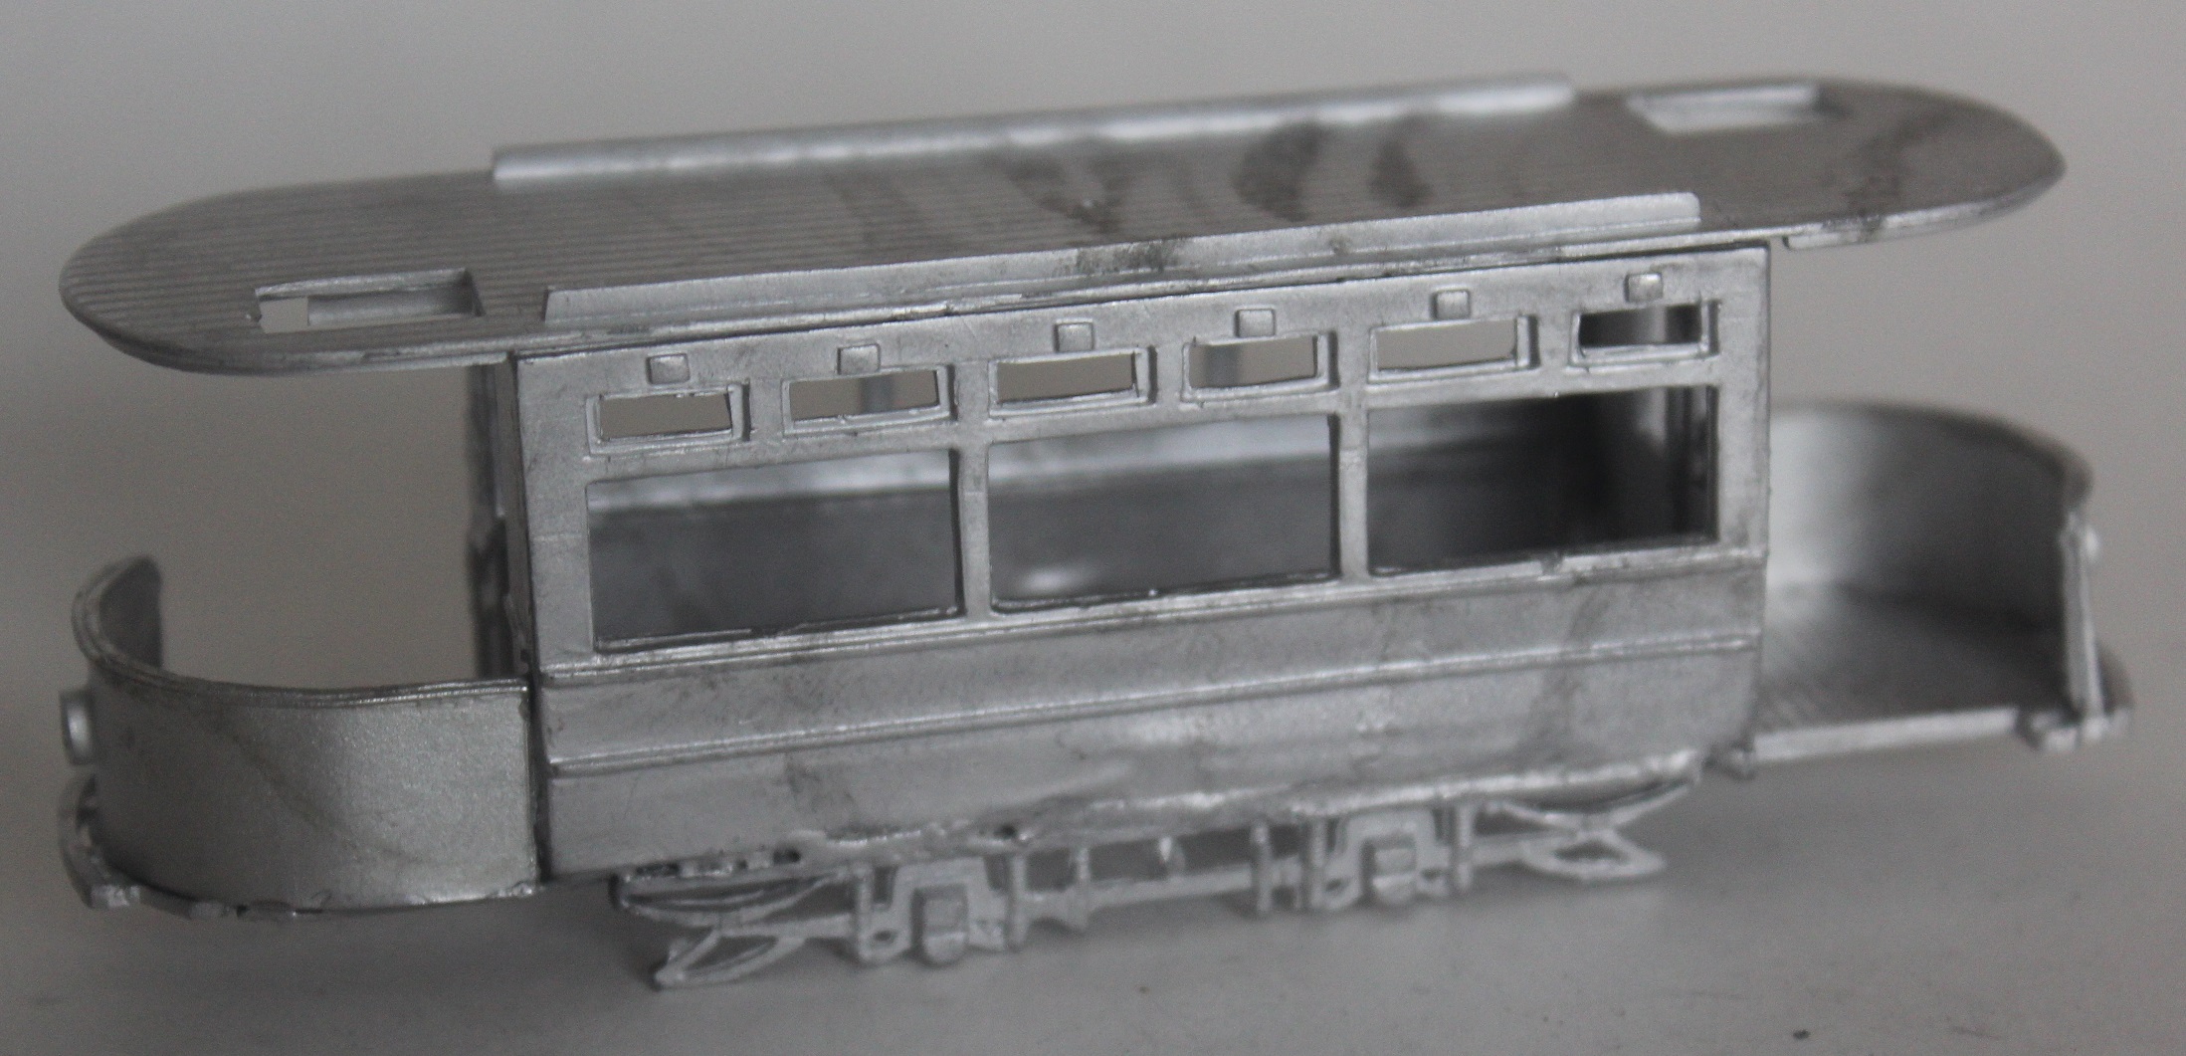
- Attach upper deck sides and carefully bend the ends and trim to fit.
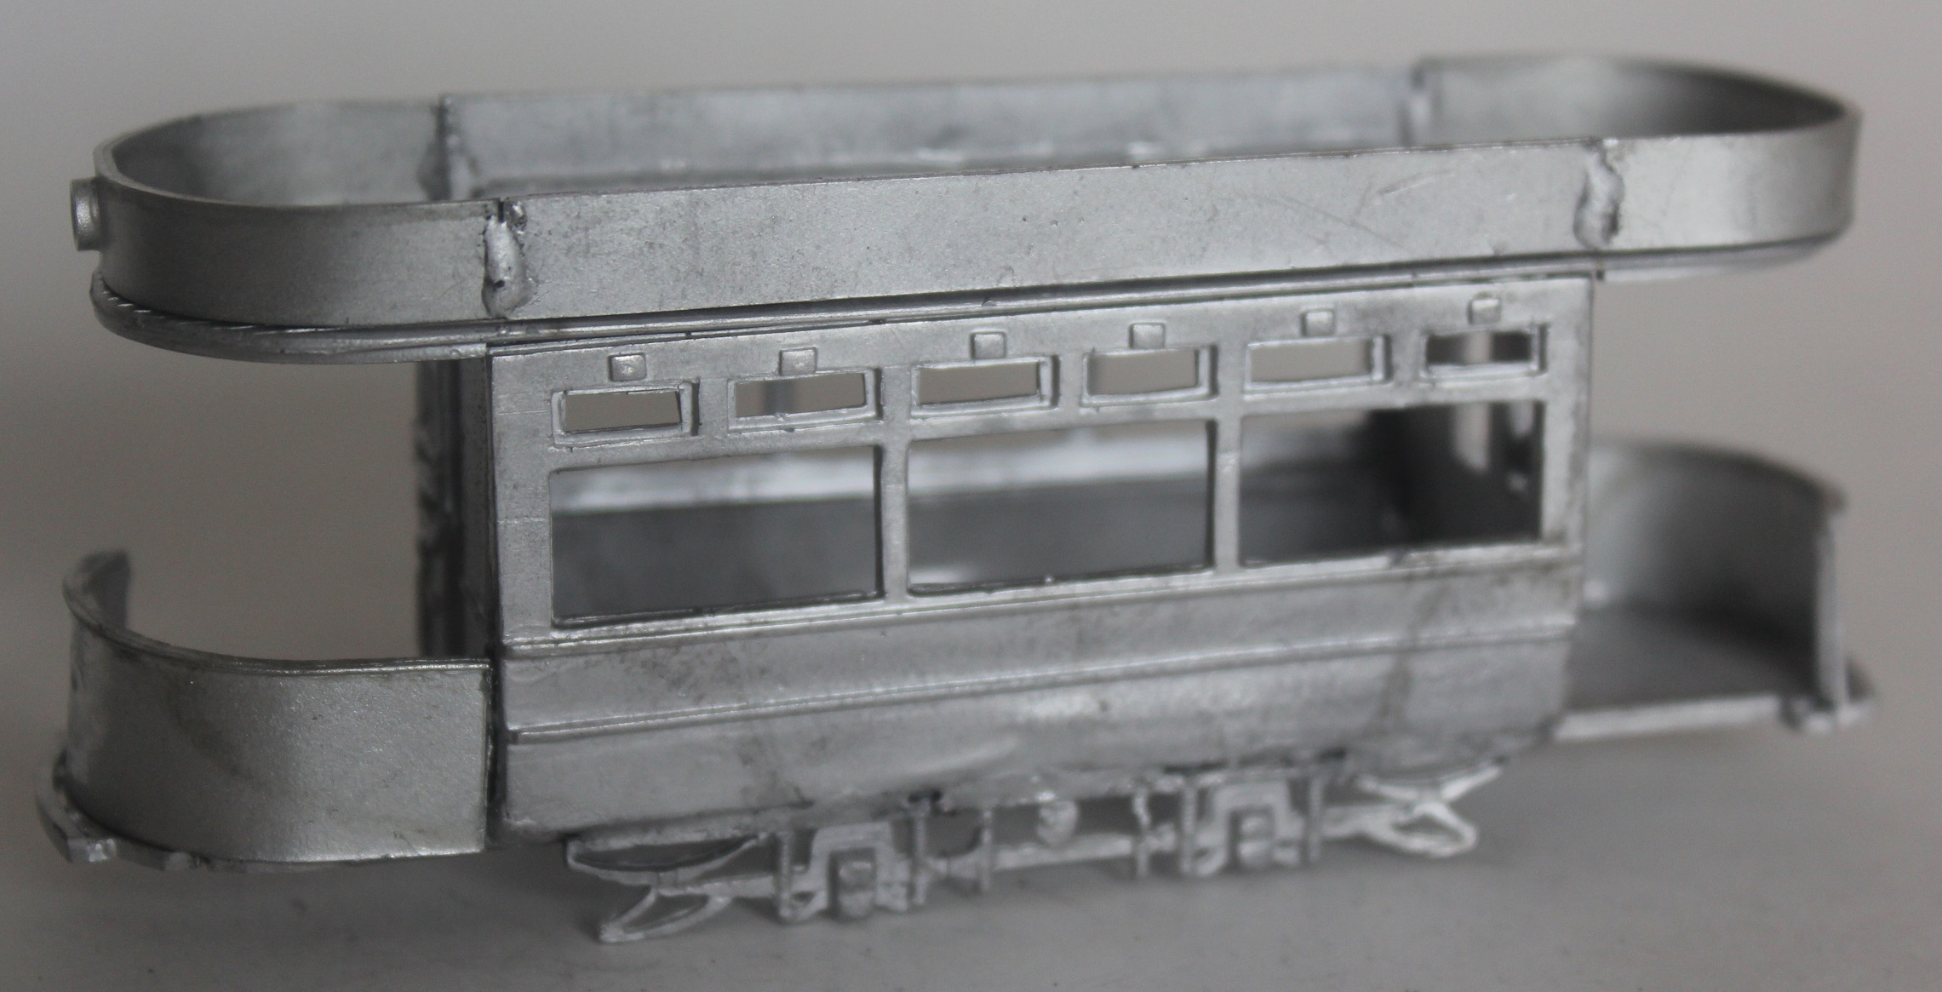
- Turn model over and fit the steps, fix the life guards under the front panels and the life trays attached to the front edge of the truck sides so they do not interfere with the mechanism.
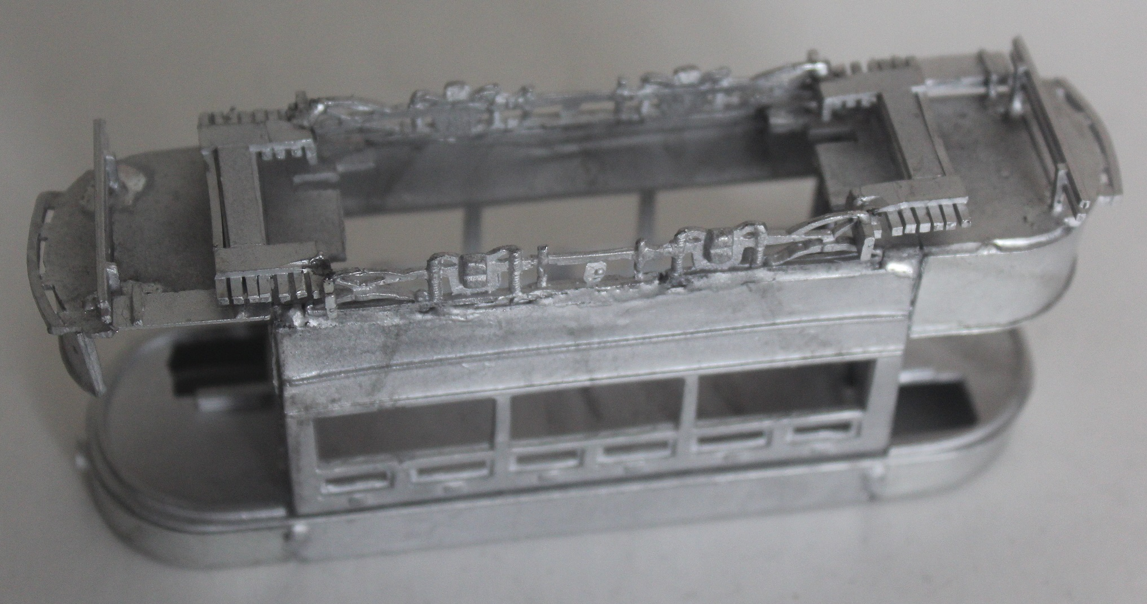
- Fit the stairs (unless you wish to paint them first).
