Motorising the EFE Leeds Horsfield tram model

The first stage is to dismantle the diecast Horsfield tram.
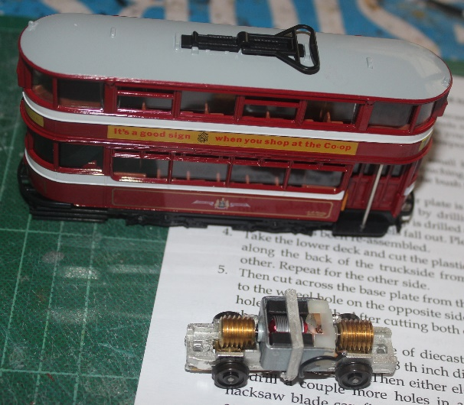
- Inside the tram are 2 bright metal rods running from floor to roof. Turning the car upside down you will see the ends of these rods in two bushes in the keeper plate. These bushes have to be removed.
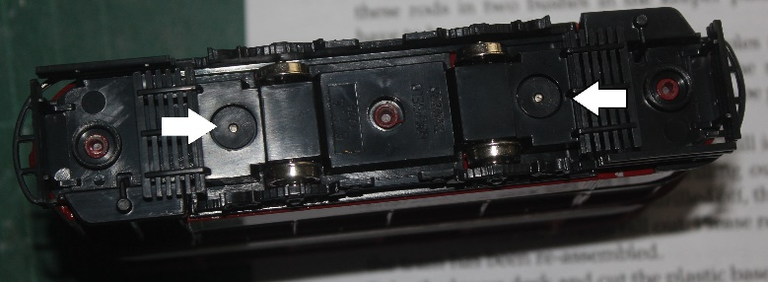
- To remove the bush, drill four small holes (about 1 mm in diameter) into the bush, just touching the rod. These holes relieve the pressure and allow the bush to be prised off the rod in one piece.
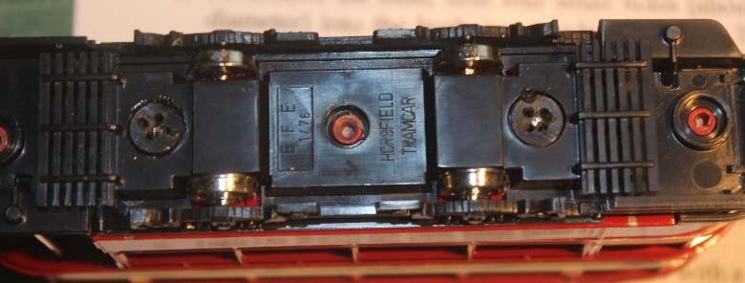
- At this point the plastic keeper plate is still in place under the lower deck. This is removed by drilling out the rivet in the centre. 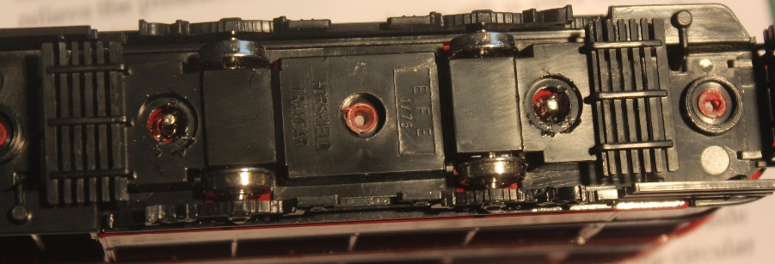
When the splayed top is drilled off, the keeper plate can be removed and the wheels fall out. Please retain all parts until the tram has been re-assembled.
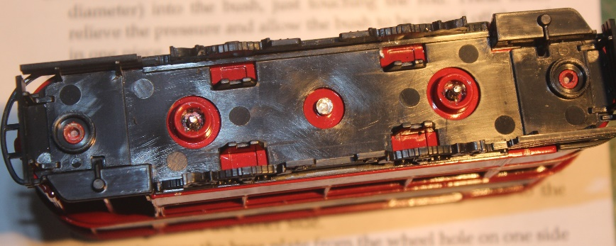
- Take the lower deck and cut the plastic base with a sharp knife along the back of the truckside from one wheel hole to the other. Repeat for the other side.
- Then cut across the base plate from the wheel hole on one side to the wheel hole on the opposite side just missing the circular hole for the bush. After cutting both ends a rectangle of plastic should drop out.
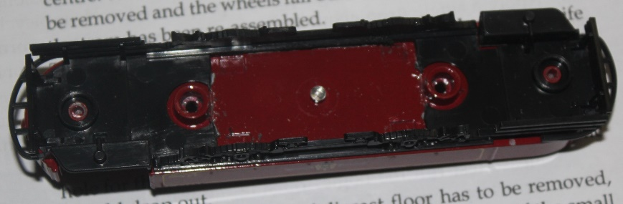
- Now the same size piece of diecast floor has to be removed, first drill a hole about 1/8 th inch diameter in one of the small recesses in the floor. Then either elongate the hole with a file or drill a couple more holes in a straight line, so a junior hacksaw blade can fit into the hole. Take care not to scratch any paintwork. Use a piece of cloth to hold the body and remove all swarf every few minutes, as it can be very abrasive.
- Open the hole to the correct size for the motor with a file.
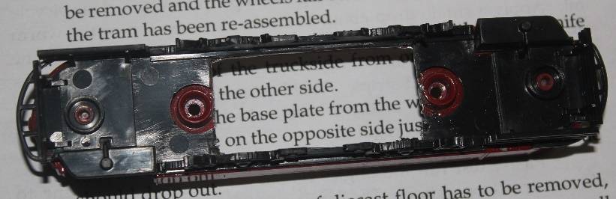
- Remove the middle section of the plastic seating module to allow the motor to fit. Then reassemble the upper & lower decks making sure that the seats are all facing the same way.
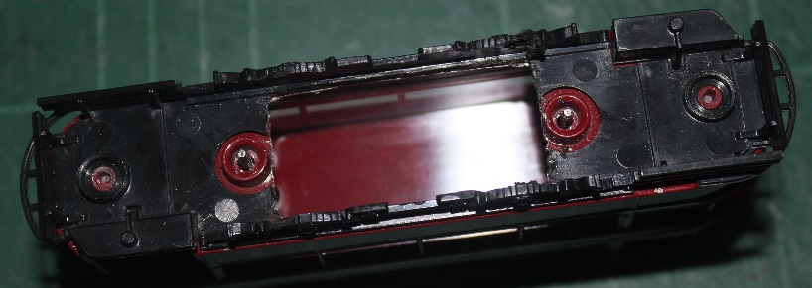
- Cut the lifeguards from the keeper plate allowing them to fit over the holes for the bushes.
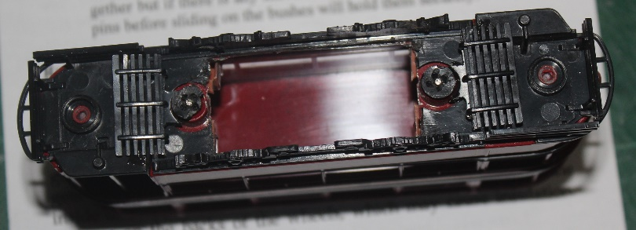
- The final job was to assemble all of the parts, making sure that the seats are all facing the same way. Use the bushes to hold everything together but if there is any movement, a dab of superglue on the steel pins before sliding on the bushes will hold them securely. The motor can then be push fitted into the space.
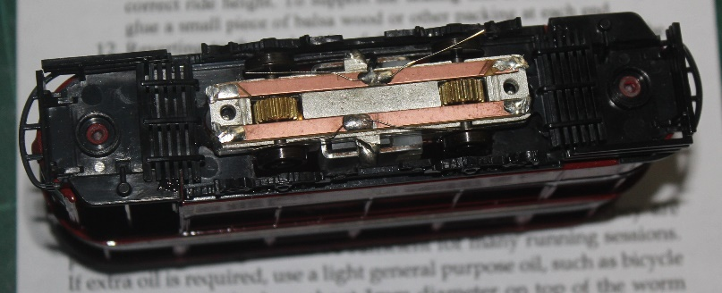
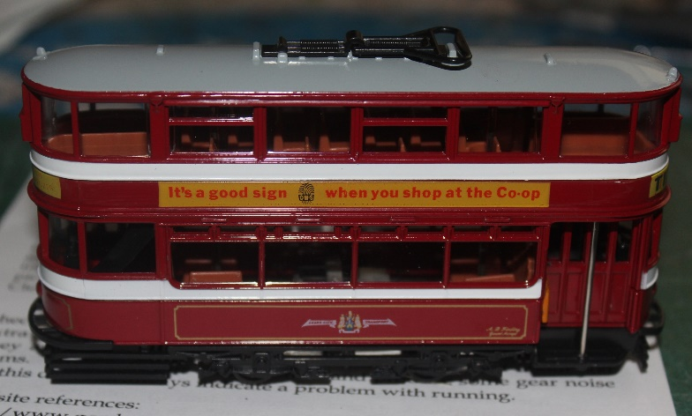
Alternatively remove the 2 metal rods from the car, then glue the body together, then the motor can be screwed to the base using self-tapping screws.
Running and servicing
The bogies are checked, oiled and test run before they are packed. This oiling should be sufficient for many running sessions. If extra oil is required, use a light general purpose oil, such as bicycle oil. Apply a single drop about 1mm diameter on top of the worm gear, on the motor axle bearings only outside the motor (ensure none gets inside the motor) and underneath on the centre of the steel axles inside the copper-clad strips. Avoid oil and dirt contaminating the pickups on the backs of the wheels, which may cause insulation. Clean the wheel treads regularly.

Web site references:
http://www.gordonstrams.net/MCTpage4.htm

© KW Trams 2015 21/07/15

